Ghulam Ishaq Khan Institute of Engineering Sciences and Technology, Topi, Pakistan.

**Group Members**

Muhammad Adeel 2022331

M. Hamza Mehmood Zaidi 2022379

Nauman Ali Murad 2022479

Hassan Rais 2022212

**Course:** DS331 – Data Warehousing and Business Intelligence (Theory & Lab)

**Instructors:** Dr. Ayaz Umer & Engr. Hafiz Syed M. Muslim

**Project Title:** Analysis of the 7th Population Census of Pakistan

**Submission Date:** 9/12/2022

**Dashboard Snapshots:**

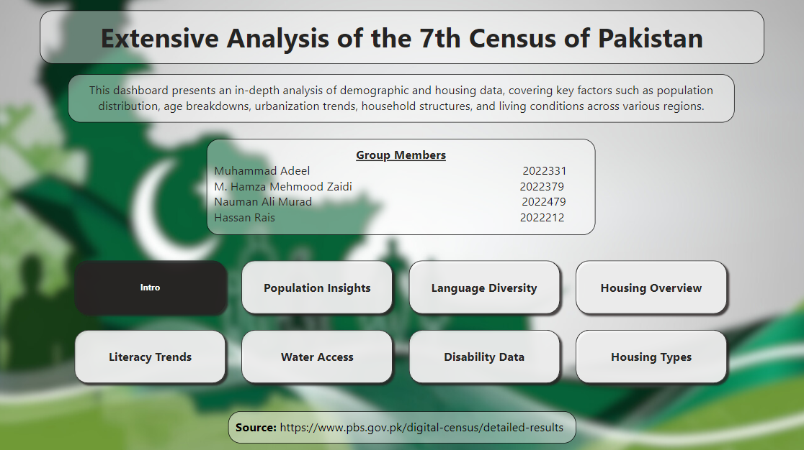

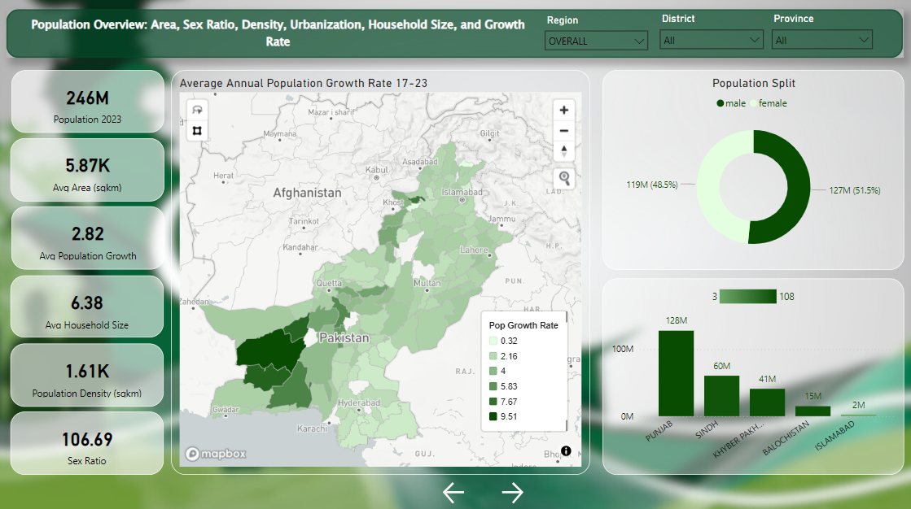

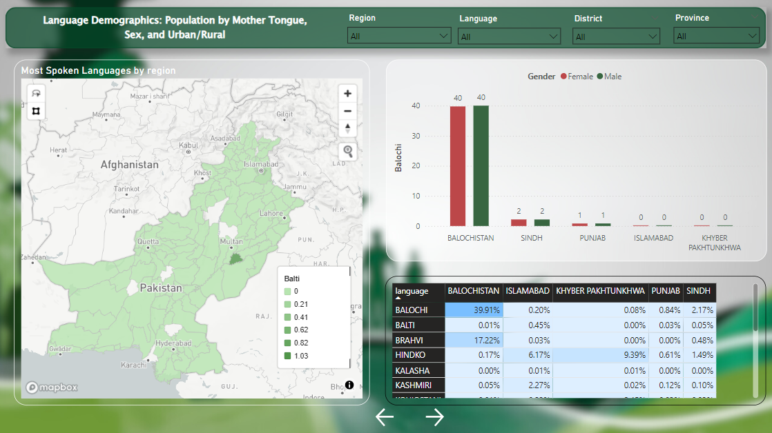

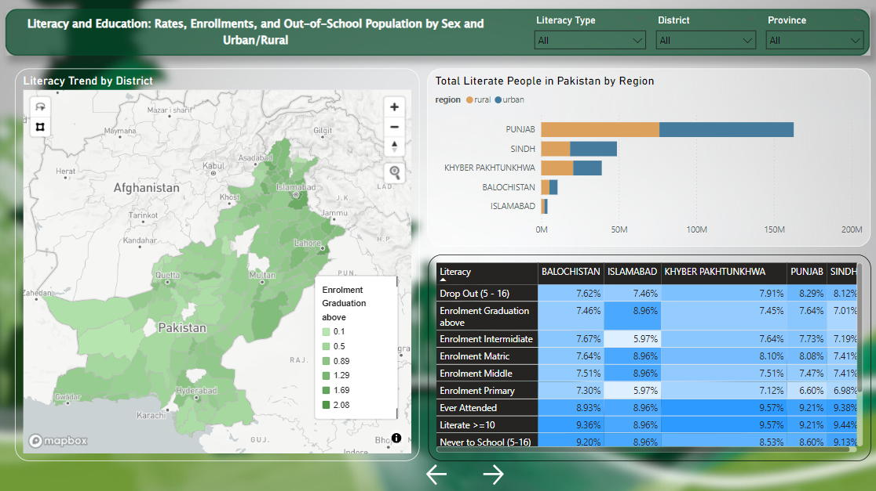

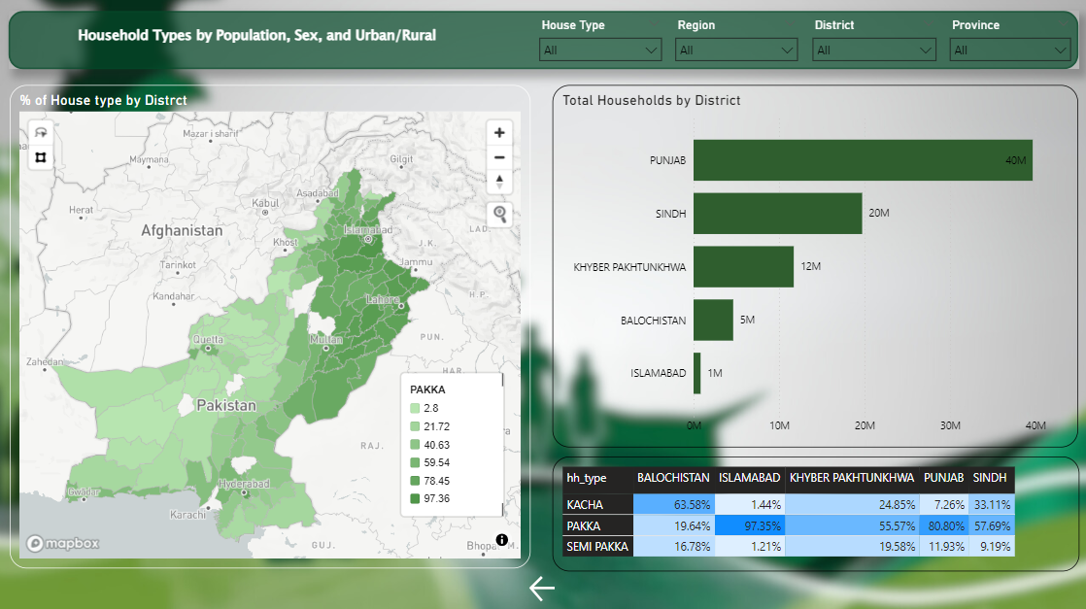

**Executive Summary**

The **2023 Digital Census of Pakistan** provides an unprecedented look into the nation’s demographic, linguistic, and socio-economic dynamics. This report explores key trends, disparities, and opportunities identified through an extensive analysis performed using **Power BI**, incorporating **DAX queries**, **Mapbox visualizations**, and parameterized metrics.

Key findings highlight stark inequalities in education, energy access, water infrastructure, and housing conditions, as well as the linguistic and cultural diversity across provinces. Insights emphasize critical areas for intervention, including equitable resource distribution, sustainable energy solutions, and education reforms.

**Dataset Overview**

The dataset, sourced from the [**Pakistan Bureau of Statistics Digital Census Results**](https://www.pbs.gov.pk/digital-census/detailed-results), provides granular insights into:

* **Population demographics:** Including total population (246M), gender distribution (male: 127M, female: 119M), population growth (2.82%), and sex ratio (106.69 males per 100 females).
* **Housing and infrastructure:** Types of housing (Pakka, Kacha, Semi-Pakka), household size (average 6.38), and access to utilities.
* **Water sources:** Usage of filtered, piped, and motorized pumps across provinces.
* **Languages:** Regional linguistic patterns highlighting cultural diversity.
* **Geographical details:** Land area (5.87K sq km) and population density (1.61K/sq km).

The dataset has the following attributes:

1. **Building Structures**
2. **Disabilities**
3. **House Structure**
4. **Housing Characteristics: Fuel, Lighting, etc.**
5. **Language**
6. **Literacy**
7. **Population Insights**
8. **Source of Drinking Water**

The dataset offers a balanced view of urban and rural dynamics, providing a foundation for targeted policymaking.

**Data Preprocessing**

The dataset underwent rigorous preprocessing to ensure reliability and accuracy:

1. **Cleaning:** Addressed missing values, standardized province and language names, and removed outliers.
2. **Transformation:** Aggregated linguistic and housing data for provincial comparisons.
3. **Categorization:** Segmented population data into urban and rural categories.
4. **Mapping:** Geo-referenced water infrastructure and housing data for enhanced visualization.

**Feature Selection**

Selected features reflect critical socio-economic and infrastructural parameters:

1. **Housing Type:** Distinguishing Pakka (55% in KP), Kacha (24.85%), and Semi-Pakka (19.58%) housing for regional development insights.
2. **Languages:** Highlighting linguistic diversity, e.g., Punjabi dominance in North Punjab vs. Saraiki in South Punjab, and Balochi’s prevalence in Balochistan (39.91%).
3. **Water Access:** Examining reliance on improved sources (e.g., Sindh: 32.57%, Balochistan: 21.67% outside sources).
4. **Energy Access:** Insights into solar panel usage (7% nationally, high in Balochistan rural areas).

These features were selected for their relevance to understanding disparities and resource utilization patterns.

**Analysis**

**Descriptive Statistics**

* **Population:**
  + **2023 Population:** 246M (127M males, 119M females).
  + **Population Density:** 1.61K/sq km.
  + **Growth Rate:** 2.82%.
* **Housing:**
  + In KP, **55%** of houses are Pakka, followed by Kacha (24.85%) and Semi-Pakka (19.58%).
  + Urban areas lead in solar adoption (e.g., 33% in rural Balochistan).
* **Water Access:**
  + Sindh: High use of filtered water (3.54%) and improved sources (32.57%).
  + Islamabad: High reliance on motorized pumps (16.61%).
  + Balochistan: Heavy dependence on outside sources (21.67%).
* **Languages:**
  + North Punjab: Predominantly Punjabi.
  + South Punjab: Saraiki dominance.
  + Balochistan: Balochi (39.91%), Brahvi (17.22%), and Pashto (2.10%).

**Visual Representations**

(Insert charts, tables, and Mapbox visualizations here)

* **Bar Chart:** Housing types by province.
* **Geo-Map:** Solar adoption and water access across regions.
* **Pie Chart:** Linguistic distribution in Punjab and Balochistan.

**Insights and Recommendations**

**Key Insights**

1. **Housing and Energy:**
   * The reliance on wood for cooking (over 50%) and low solar adoption indicate a need for sustainable energy solutions.
2. **Water Access:**
   * Sindh’s high use of filtered water reflects water scarcity, while Balochistan’s reliance on external sources underscores infrastructure gaps.
3. **Linguistic Diversity:**
   * Distinct linguistic zones in Punjab and Balochistan highlight the need for culturally tailored education and communication policies.
4. **Population and Growth:**
   * Pakistan’s population growth (2.82%) and density (1.61K/sq km) demand urgent urban planning and resource optimization.

**Recommendations**

1. **Sustainable Energy Policies:**
   * Expand solar energy programs in rural areas, leveraging Balochistan’s high adoption rates as a model.
2. **Water Infrastructure Development:**
   * Invest in piped water systems and filtration facilities in underserved regions like Balochistan and Sindh.
3. **Targeted Education Programs:**
   * Address educational disparities through province-specific programs, prioritizing rural Balochistan and South Punjab.
4. **Urban Housing Policies:**
   * Enhance rental housing markets in urban centers like Islamabad to meet growing demand.

**Conclusion**

The **2023 Digital Census** provides a detailed lens into Pakistan’s evolving socio-economic landscape. By addressing critical disparities in housing, energy, water, and education, policymakers can drive meaningful change for sustainable development.

*This report serves as a guide for actionable strategies aimed at improving living standards and resource allocation across Pakistan.*